 Amazon Sales Analysis Dashboard:

Excel & power bi

**PROJECT REPORT**

**By**

**GROUP 20**

**DATA ANALYST**



**INTRODUCTION**

In the competitive e-commerce market, understanding sales dynamics is crucial for sustained growth. Amazon, being one of the largest online retail platforms, generates massive amounts of sales data daily.  
This project aims to transform raw Amazon sales data into actionable insights using **Excel and Power BI**. The analysis provides a comprehensive view of sales trends, category performance, and revenue distribution. The project emphasizes data cleaning, visualization, and interactive dashboards to support strategic business decisions.

The **main takeaway** from this analysis is that **sales performance showed consistent growth in the first quarter**, primarily driven by the **Electronics category**, with notable regional variations influencing total revenue.

**ABSTRACT**

This project focuses on analyzing Amazon’s sales data to uncover trends, identify high-performing products, and evaluate category-based and regional sales performance. The dataset was cleaned and processed using **Microsoft Excel** and visualized through **Power BI**. Key performance indicators (KPIs) such as **Total Sales**, **Sales by Category**, **Units Sold**, and **Monthly Sales Trend** were examined to measure overall performance. The findings indicate that **Electronics** dominate sales, while **January and March** recorded the highest revenue. These insights help guide data-driven decision-making, optimize marketing strategies, and improve product-level management.

**OBJECTIVES**

The primary objectives of this project are to:

* Analyze total sales and category-wise performance.
* Identify top-selling products contributing to revenue.
* Study monthly sales trends and seasonal variations.
* Measure KPIs to assess overall sales efficiency.
* Provide actionable insights and recommendations for improving business outcomes.

**Business Questions:**

1. Which product categories generate the highest sales?
2. What are the top-performing products by total revenue?
3. How do sales vary across months and regions?
4. What insights can guide better inventory and marketing decisions?

**METHODOLOGY & DATA ANALYSIS**

**Data Source**

The dataset used for this project was provided as **Amazon_Sales_Data_Real.xlsx**. It contains records of product categories, order details, unit prices, quantities, and order dates.

**Data Cleaning (in Excel)**

* Removed blank and duplicate records.
* Standardized column names and corrected data formats.
* Created two new columns:
  + **Year** (extracted from the Order Date column).
  + **Month** (extracted from the Order Date column).
* Fixed text-column inconsistencies (e.g., one numeric entry replaced with text).
* Used **Pivot Tables** to summarize
  + Total Sales.
  + Total Sales by Category.
  + Monthly Sales Trends.

**Data Analysis (in Power BI)**

* Imported cleaned Excel dataset into Power BI.
* Transformed data using Power Query Editor.
* Defined KPIs for **Total Sales**, **Units Sold**, **Total Profit** and **Average Unit Price**.
* Applied DAX measures for calculating monthly sales and product rankings.
* Built an **interactive dashboard** with slicers for Region and Payment mode.

**RESULTS & VISUALIZATION**

**KPIs**

| **KPI** | **Description** |
| --- | --- |
| **Total Sales** | Overall revenue generated |
| **Total Profit** | Total profit earned across all transactions |
| **Units Sold** | Number of units sold |
| **Average Unit Price** | Mean price of products sold |
| **Sales by Category** | Revenue share of each category |
| **Monthly Trends** | Month-wise variation of sales and profit |

**Dashboard Visuals**

1. **Area Chart – Monthly Sales Trend**
   * Displays total sales over months, highlighting growth and decline periods.
2. **Column Chart – Sales by Product Category**
   * Shows which product categories contribute most to total sales.
3. **Line Chart – Sales by Sub-Category**
   * Highlights top-performing sub-categories and their comparative trends.
4. **Donut Chart – Sales by Region**
   * Represents the percentage of sales contributed by each region.
5. **Bar Chart – Top 5 Performing Products**
   * Displays the top five products based on sales , sorted descending.
6. **Area Chart – Profit by Month**
   * Tracks monthly profit to observe seasonal profitability patterns.
7. **Slicers Used:**
   * **Region** – filters dashboard visuals region-wise.
   * **Payment Mode** – filters data by type of payment (e.g., COD, Online, Cards).

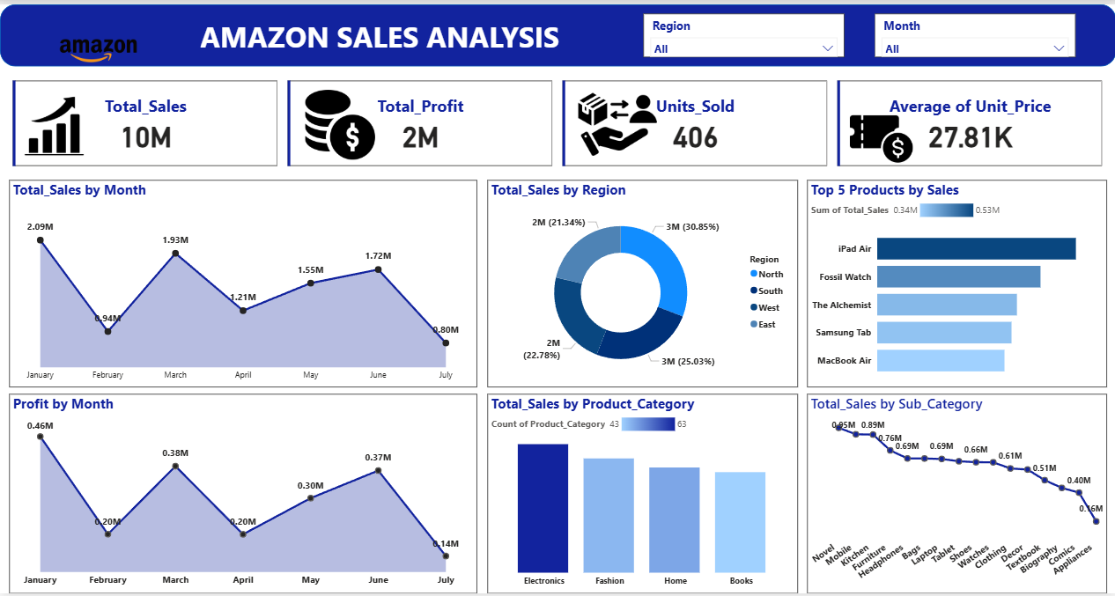

**DATA VISUALIZATION SUMMARY**

The Power BI dashboard integrates various visuals that offer a clear, interactive overview:

* **Monthly Sales (Area Chart):** Revealed strong sales in January and March, slight dips in February and July.
* **Category and Sub-Category** **Trends:** Electronics and Fashion dominated; Novel and Mobile performed well among sub-categories.
* **Regional Distribution (Donut Chart):** North and West regions led in overall revenue share.
* **Top Products (Bar Chart):** The top 5 items generated the majority of total sales.
* **Profit by Month (Area Chart):** Indicated correlation between sales peaks and profit surges.
* **Slicers (Region & Payment Mode):** Enabled interactive filtering for targeted analysis

**PROJECT INSIGHTS**

**1. Electronics Category Drives Highest Sales**

* **Fact:** Electronics accounted for the largest share of total revenue.
* **Interpretation:** Strong demand and brand recognition in electronics.
* **Recommendation:** Continue focusing marketing and inventory on this category.

**2. Seasonal Trends Observed**

* **Fact:** Sales were highest in January and March, lowest in February and July.
* **Interpretation:** Suggests seasonal or campaign-based buying patterns.
* **Recommendation:** Run promotional campaigns during low-sales months to stabilize revenue flow.

**3. Top 5 Products Generate Major Revenue**

* **Fact:** A small set of products contributed disproportionately to sales.
* **Interpretation:** These products are crucial for profitability.
* **Recommendation:** Offer bundles, loyalty rewards, or premium packaging for these items.

**4. Regional Variations**

* **Fact:** North and West regions outperformed South and East.
* **Interpretation:** Uneven distribution of marketing or logistics effectiveness.
* **Recommendation:** Adapt successful regional strategies in low-performing areas.

**5. Stable Unit Pricing**

* **Fact:** The unit price remained relatively constant across months.
* **Interpretation:** Reflects strong market positioning.
* **Recommendation:** Maintain stable pricing while introducing value-added options.

**SUGGESTIONS**

* Conduct promotional campaigns and product awareness drives in low-performing regions.
* Study customer preferences in the South and East to customize offers accordingly.
* Maintain strong inventory and availability for these bestsellers.
* Introduce bundle offers or similar premium products to leverage this demand.
* Analyze if low-selling products need price adjustments or discontinuation
* Focus on expanding electronics and fashion categories with new launches.
* Improve marketing strategies for books — such as discounts or combo offers.
* Optimize inventory allocation based on sales performance.
* Reassess pricing and cost structure during low-profit months.
* Focus on improving sales of high-margin products.
* Implement seasonal profit-boosting strategies (e.g., cross-selling).
* Increase digital marketing for underperforming subcategories.
* Launch discount campaigns or combos for low-demand items.
* Retain focus on electronics, as it consistently drives sales growth.

## ****CONCLUSION****

This project successfully demonstrated how data-driven techniques can extract actionable insights from sales data. Through systematic cleaning, transformation, and visualization using Excel and Power BI, the Amazon sales dataset revealed valuable information on category dominance, product performance, and seasonal trends.

The analysis concludes that **Electronics** remain the core driver of sales, supported by strong performance in **North and West regions**. Implementing strategic campaigns during low-sales months and expanding high-performing product lines can significantly enhance future profitability.

Overall, the Power BI dashboard offers a **comprehensive, interactive, and insightful view** of Amazon’s sales performance, supporting smarter business decisions and operational efficiency.